Clean Air Day Activities for Schools

For Clean Air Day, we have two possible ideas for activities with schools which we are suggesting to local authorities.

- Clean Air Route Mapping project launch

In advance:
- Encourage as many schools as possible to produce clean air route maps for their schools, with a particular focus on those on or near main roads.
- Schools can download our mapping project toolkit and prepare for the day’s activities.
On the day:
- Lesson: One class (suggest year 5 or 6, or the eco council) would have a lesson on air quality and schools (either using our video-recorded lesson, or using our powerpoint presentation with reader notes if they’d like to deliver it themselves).
- Look at maps: The class will look at a pollution map of their area and identify which are the most polluted / least polluted roads.
- Produce map elements: In the second part of the class, they would produce the elements of the map – drawings of their favourite places in the area, background map of the roads (colouring the polluted roads red), logo or name for the map.
- Share images: The school shares images / videos of the activity on social media

After the class:
- Either a teacher or a parent with graphic design skills puts together the elements of the map.
- The map can be printed and all children at the school receive a copy, and it could also be printed as a large banner to put up outside the school.

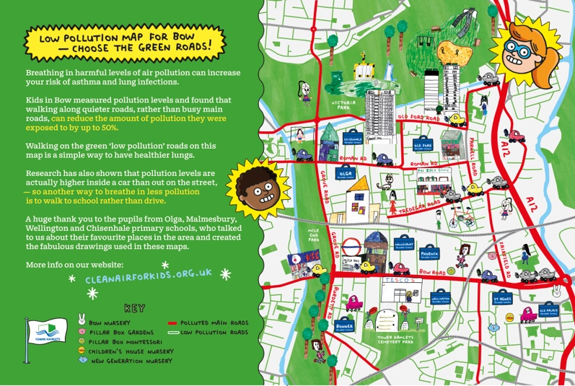

- Raising Awareness and posters / letter writing

Schools commit to raising awareness about pollution at their school on Clean Air Day, and can use the resources in our ‘Raising Awareness’ toolkit:
In advance:
- Schools download the toolkit, and can send out the letter to parents to let them know the activity is happening.
- Schools can arrange for a ‘Clean Air in the Making’ banner to be sent to them (see below), and take photos of some pupils by the banner. We can provide the council with the file for printing (we suggest the banner is sent a day or two before, so you have some visuals for use on Clean Air Day itself).
On the day:
- Lesson: One class (suggest year 5 or 6, or the eco council) would deliver a lesson on air quality and schools (either using our video-recorded lesson, or using our powerpoint presentation with reader notes if they’d like to deliver it themselves).
- Activity: In the second half of the lesson, pupils can create a poster or video message about air quality, for use on the school’s social media/ school newsletter, and share with the local authority. Or they could write a letter to a local politician about clean air and schools.
The learning outcomes for these projects are that pupils will understand
- What pollution is and what creates it;
- What can happen to us if we breathe in too much pollution;
- Why it’s important for schools to have clean air;
- What you can do about it

